Mona & Anton

-User Experience of wearable technology

-UX and Ergonomics

-Wearable sensors

-What is NASA already doing?

Cameron & Stuart (Design)

**Methods For Tracking Inside**

-Motion Tracking and IR with Stickers

-cameras and facial recognition…

**Methods For Tracking Outside**

-Sensors at key points integrated into suit

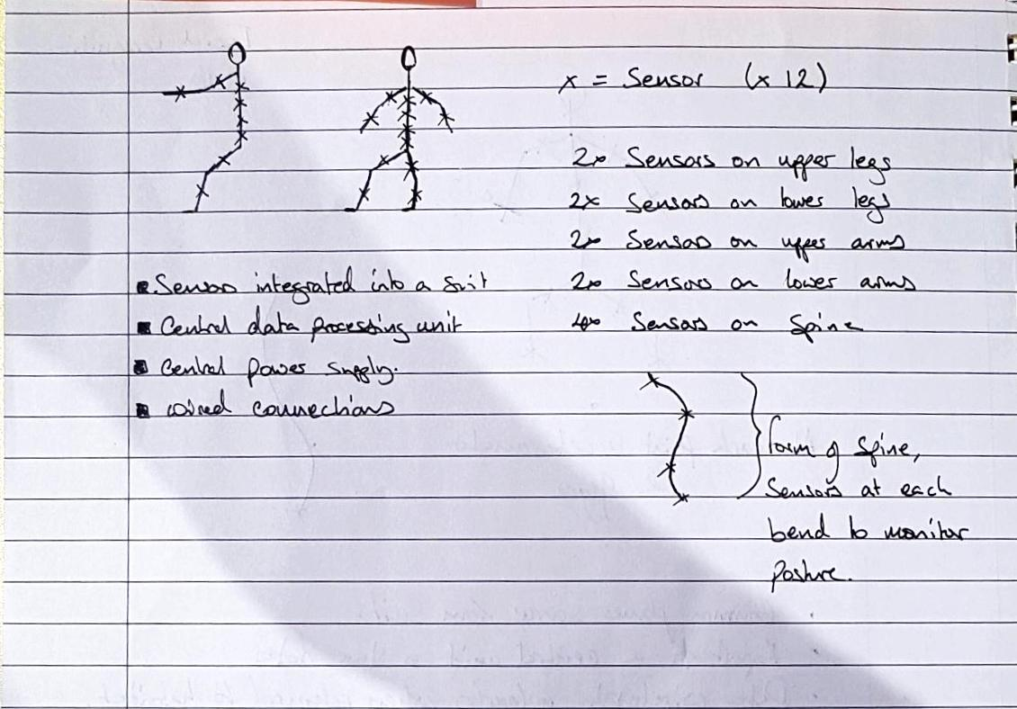

Each ‘Sensor’ is comprised of an accelerometer and gyro to measure a points motion and orientation in free space. Within the suit/skin, sensors are connected by wires to a central power source and processing unit, this helps to keep individual nodes small by removing the need for individual power sources. Central unit can be responsible for managing the sensors, storing their data and distributing data to a database or database. X’s marked on the stick men represent the sensors and the power supply and controller unit can be positioned in any comfortable position. Note multiple sensors along key points of the spine to monitor posture.

To make internal motion tracking systems more user friendly it would probably be best to use cameras and AI to identify individual team members inside, this way we could have some level of monitoring inside without the astronauts needing to wear a suit at all times.

Data can be analysed and collated into a single user interface, displaying a record of an individual's activity and how it compares with ideal motions for the tasks they completed. For real time analysis/ notification, a lite system would need to be in operation to inform the user of particularly damaging activity and to display data.

Other technologies such as electroactive polymers could be employed to give tactile feedback to the user, perhaps a light pressure applied to the area of concern to alert the user to a problem. Electroactive fabric can take specific forms when provided a current they could be used in this way.

What current technologies are currently being used

What companies are making these/ using these.

Real life examples.

Hamzah

Darsh